A NIGHT IN TOKYO ~ UNA NOCHE EN TOKYO


GALA & SILENT AUCTION to benefit La Joven Guardia del Teatro y la Danza Latina
Traditions at the Links, 5900 N. Burdick St. E. Syracuse, NY 13057

Join us Friday, July 24, 2026 as we celebrate 27 years of La Joven Guardia del Teatro y la Danza Latina at our GALA, A Night in Tokyo / Una Noche en Tokyo. We will honor the many accomplishments of the group - bringing award-winning plays to local schools and community groups since 1999; participating in festivals throughout the area; and celebrating Hispanic Heritage month in CNY.
These activities have empowered our kids educationally and emotionally, motivated
them to look forward and plan their futures. All was accomplished with minimal resources!

Pre-Gala Reception ~ 6 pm – 6:30 pm
PLEASE DONATE AN ITEM FOR OUR SILENT AUCTION
Item:
Dinner & Presentations ~ 6:30 pm - 7:30 pm Silent Auction ~ 6:00 pm – 9:30 pm
Dancing ~ 7:30 pm – 10 pm

At the Gala we will honor community members who have supported us over time. All funds beyond Gala expenses will provide programming to help our theater youth and children move toward their future goals.
Purchase tickets: @ $95/person via La joven guardia del teatro latino (jgteatrolatino.com) Joven Guardia web site or pay by check; mail to address below. Or reserve Table(s) of 10 @ $850.

Reserve space in Gala program booklet for: DEADLINE for B & W Camera Ready Ad is June 15, 2024.
Full page ad @ $250 (8” x 5”) COLOR Quarter page ad @ $50 (2 ½” x 4”) B & W
Half page ad @ $150 (4” x 5”) B & W Message up to 18 words @ $25 B & W
TOTAL AMOUNT DUE: $
Checks for Ads should be written to La Joven Guardia del Teatro (Gala 26 on memo line). Please mail check along with this registration form to: La Joven Guardia Gala AD
In appreciation for your consideration, ℅ Shirley Novak
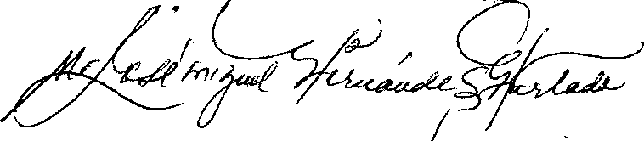
In appreciation for your consideration,.
2669 E Genesee St.
JoséMiguel Hernández Hurtado
Syracuse, NY 13224

La Joven Guardia del Teatro y la Danza Latina
~ ~ ~ ~ ~ ~ ~ ~ ~ ~ ~ ~ ~ ~ ~ ~ ~ ~ ~ ~ ~ ~ ~ ~ ~ ~ ~ ~ ~ ~ ~ ~ ~ ~ ~ ~ ~ ~ ~ ~ ~ ~ ~ ~ ~ ~ ~ ~ ~ ~ ~ ~ ~ ~ ~ ~ ~ ~ ~ Questions? E-mail or call: JoséMiguel Hernández – miguelangel177@aol.com 315.857.4537
Kimberly Santana - kimberlysantana246@gmail.com 315.796.4748
Shirley Novak - shirleynovak@yahoo.com 315.882.1061

Donor Name________________ Company (if applicable) ____________________________

Address City State Zip
Phone E-mail
Paying by: VISA MC AMEX Card Number
I will need an invoice please. CVV# Expiration

Auction Item __________________________________________ Item value ________

